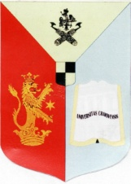
Universitatea din Craiova
RECTORAT
Tradiție, Performanță, Viziune

Craiova, Str. Al.I. Cuza, nr. 13, 200585,
tel: +40-351-403145, fax:+40-251-411688, www.ucv.ro
e-mail: rectorat@central.ucv.ro, rectorat@ucv.ro

MINISTERUL EDUCAŢIEI NAȚIONALE
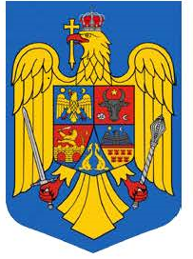

INTERNATIONAL CONFERENCE

INTERNATIONALIZATION IN HIGHER EDUCATION:
Changes and Challenges
University of Craiova
October 18, 2019

REGISTRATION FORM

1. | Name of presenter
2. | Academic title
3. | Affiliation
4. | E-mail address
5. | Title of paper
6. | Section (thematic area)
7. | Abstract (100 words)
8. | 5 keywords
9. | Brief biographical note  (100words)

Submission instructions
Proposals (maximum 100 words) for 20-minute presentations and a short autobiographical note (maximum 100 words) can be sent to the organizers at relint@ucv.ro by September 25, 2019. Notification of acceptance will be sent by October 2, 2019.

The language of the conference is English.

Contact: relint@ucv.ro
For further details you can also contact Sorin Cazacu at cazacu.sorin@ucv.ro.

