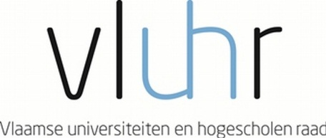 

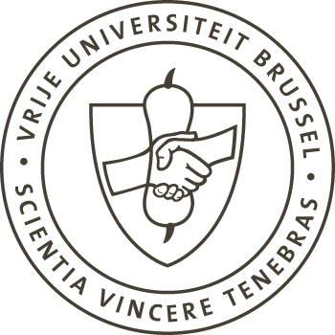

**Master Mind Scholarships**

***Fellowship Programme for Excellent Students***

***Vrije Universiteit Brussel***

**Academic year 2016 – 2017**

The Government of Flanders awards up to 45 scholarships to outstanding Master students. The programme aims to promote the internationalization of the Flemish Higher Education, as stated in the Action Plan for Student Mobility, *Brains on the Move* (September 2013).

The Vrije Universiteit Brussel applies on behalf of the student.

**General eligibility requirements**

* The applicant is registered as a full-time student at a higher education institution (hereafter ‘Home Institution’) at the moment of application, and applies to take up a Master degree programme at the Vrije Universiteit Brussel (VUB)
* The applicant should have a high standard of academic performance and/or potential. He/she meets all academic entrance criteria, including relevant language requirements, for entering the Master programme in question offered by the VUB.
* The Home Institution of the applicant and the VUB have signed a cooperation agreement.
* Students from all countries can apply. The Home Institution is located outside of Flanders.

**Modalities**

* The duration of mobility is minimum 1 academic year and maximum the full duration of the master programme. If the student obtains less than 45 ECTS in the first year, then he/she loses the scholarship in the second year.
* The incoming student is awarded a scholarship of maximum €7.500,- per academic year.
* The Vrije Universiteit Brussel will ask the applicant for the lowest tuition fee rate. This tuition fee has to be paid per year of enrolment. For your information: for the academic year 2015-2016 this tuition fee equals 105 euro.
* The Vrije Universiteit Brussel submits the application, on behalf of the student. If a scholarship is awarded to the student, then the Vrije Universiteit Brussel is committed to accept the student.
* The program holds for all study areas.
* Information about the Master programmes taught at the Vrije Universiteit Brussel can be found at <http://www.vub.ac.be/en/stuyd/masters>
* Information about the language requirements can be found at <http://www.vub.ac.be/en/studying-at-the-vub/language-requirements>

**Application**

The application needs to be submitted to the Vrije Universiteit Brussel – International Relations and Mobility Office the latest on 29th February 2016, with the exception of the European master of science in Photonics and the Master of science in Urban Studies for which the application deadline is 3rd February 2016.

**Timing**

* Deadline for application: 29th February 2016 (with the exception of the European master of science in Photonics and the Master of science in Urban Studies for which the deadline is 3rd February 2016.
* Deadline screening of files by the VUB: 24th March 2016
* Deadline online application (VUB): 25th March 2016
* Upload of documents by students: 31st March 2016
* Sellection: April 2016 (A Flemish selection committee awards the scholarships, in cooperation with the Flemish Department of Education and Training)
* Announcement of selection results: May 2016
* Start of mobility: September 2016, for the academic year 2016-2017

Should you have questions about the scholarship programme, you can contact [Hilde.De.Haseleer@vub.ac.be](mailto:Hilde.De.Haseleer@vub.ac.be)