Joint International Conference of
Doctoral and Post-Doctoral Researchers
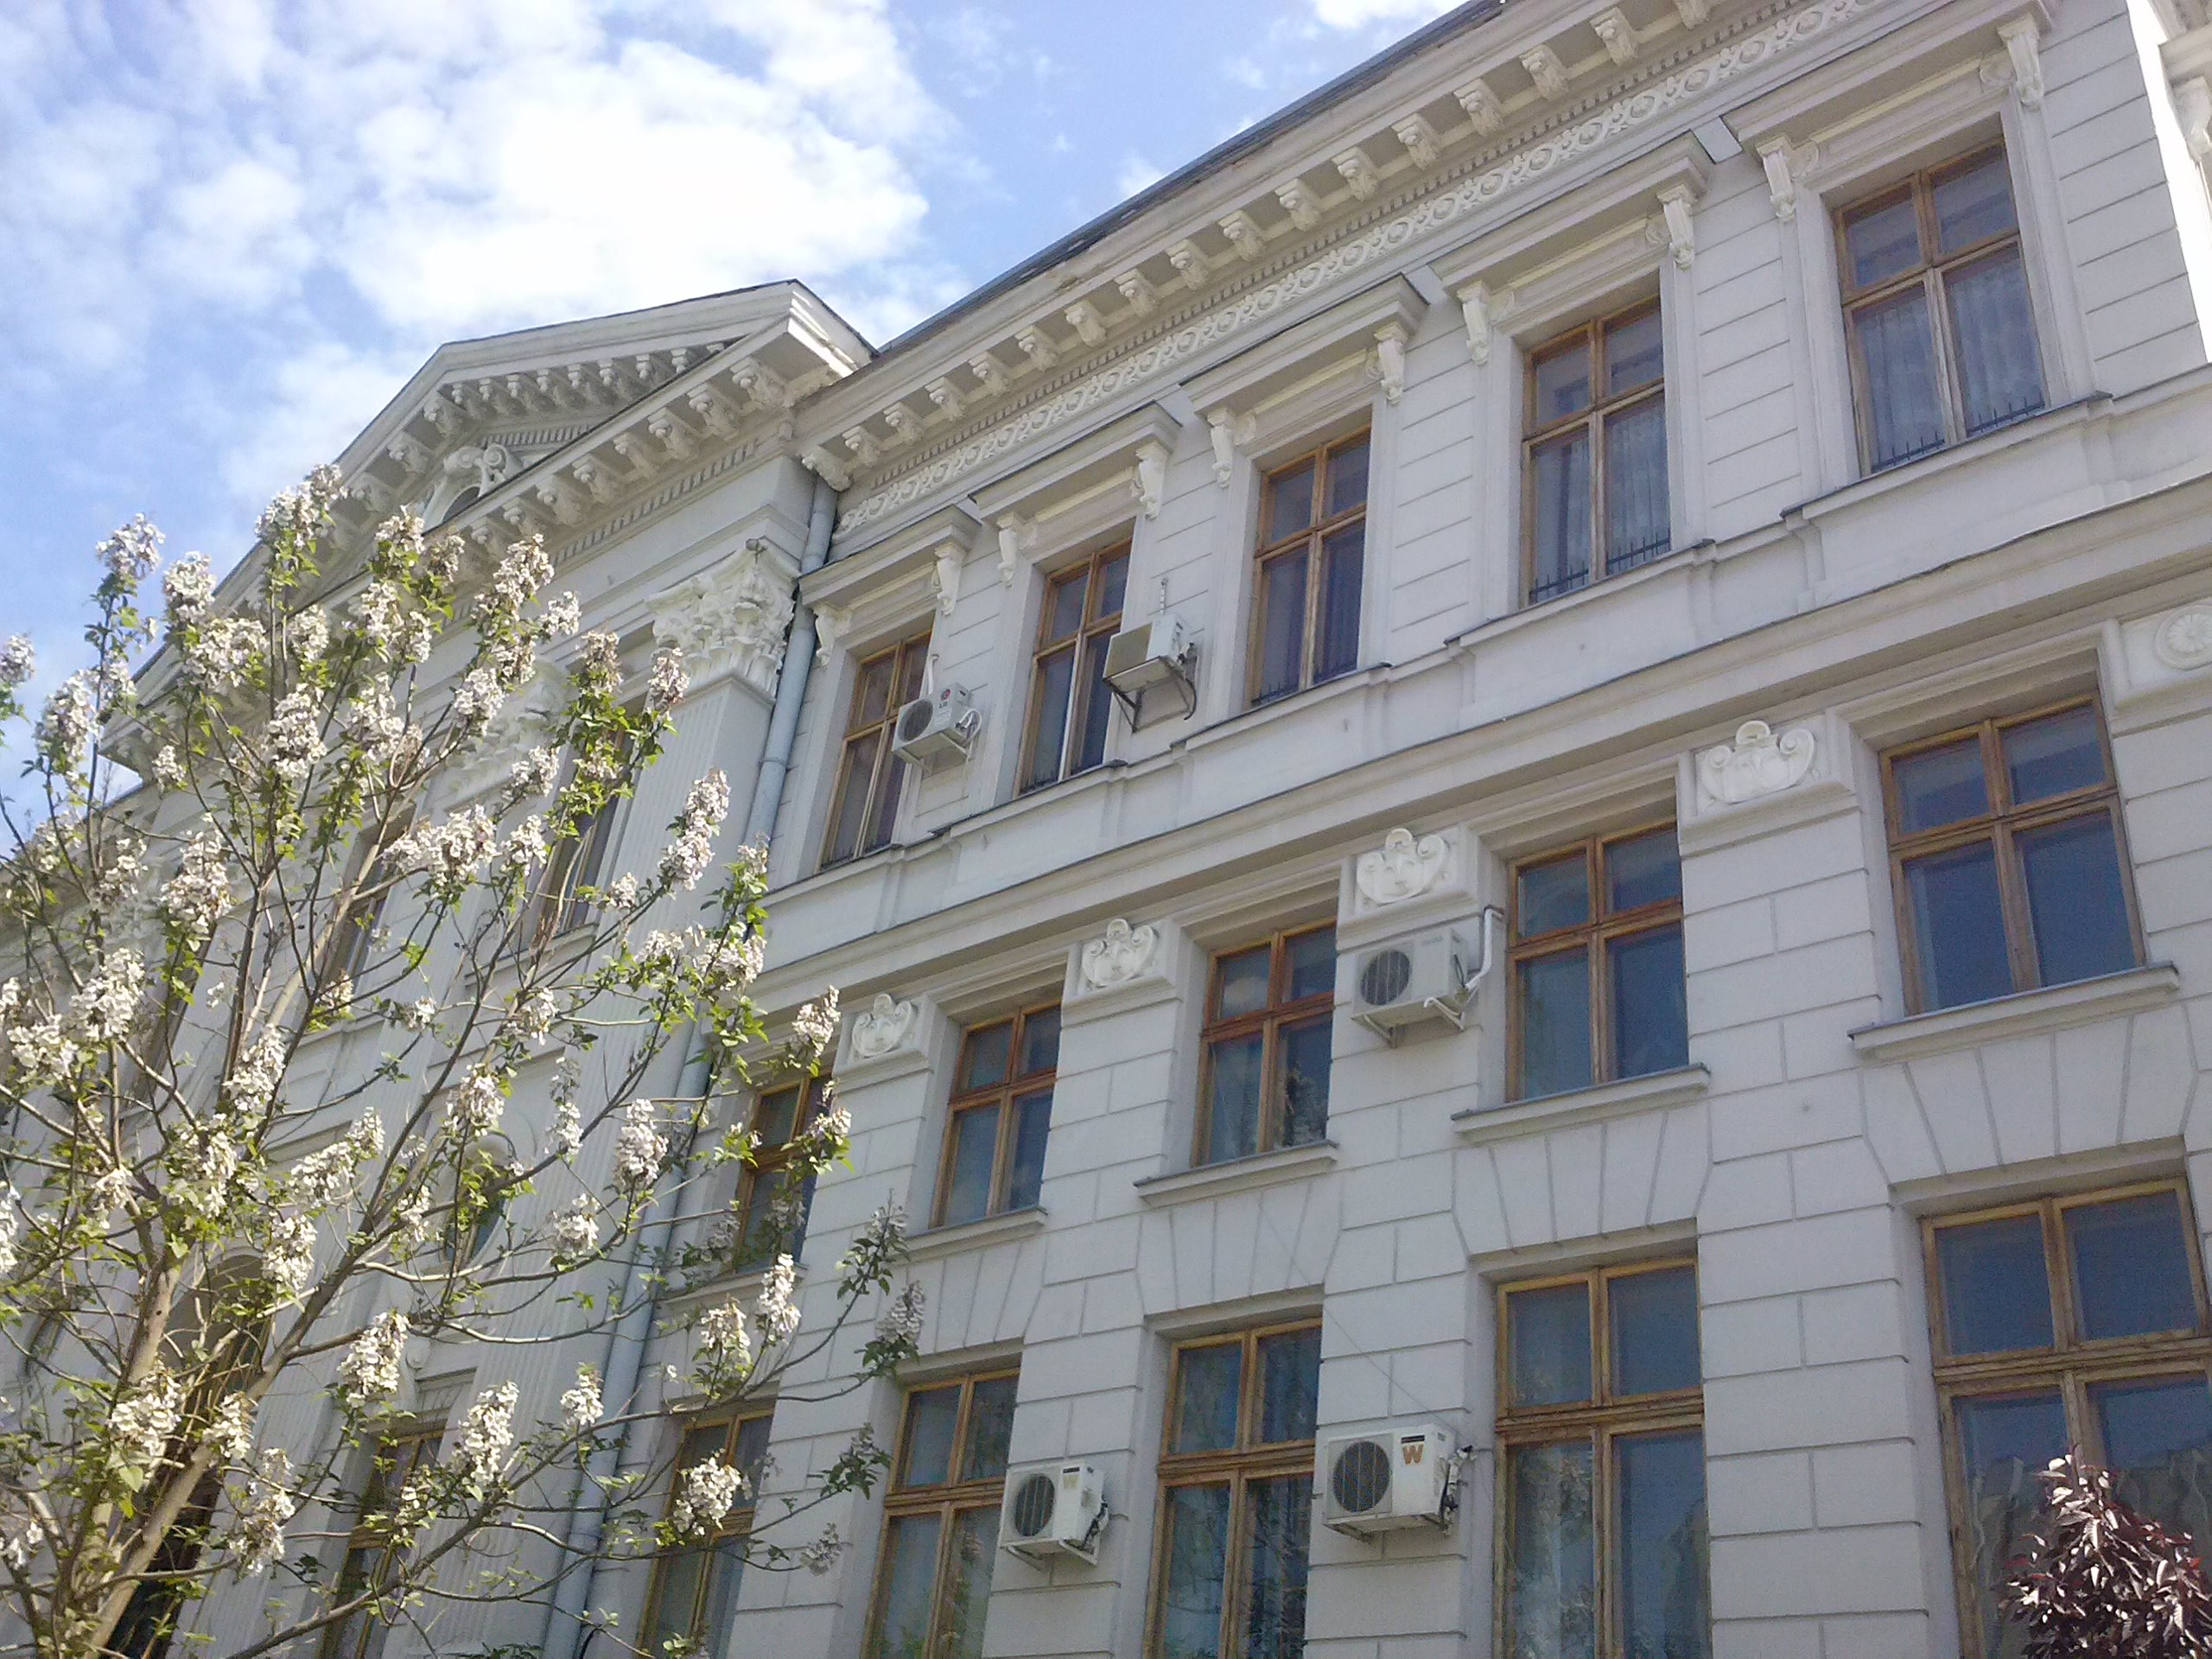

Conference Panels
Panel 1: Engineering and Exact Sciences
CORE PANEL 1.1. Doctoral research within Engineering and Exact Sciences
CORE PANEL 1.2. Post-doctoral research within Engineering and Exact Sciences

Panel2: Social and Humanistic Sciences
CORE PANEL 1.1. Doctoral research within Social and Humanistic Sciences
CORE PANEL 1.2. Post-doctoral research within Social and Humanistic Sciences

Craiova
12-13 September 2014

